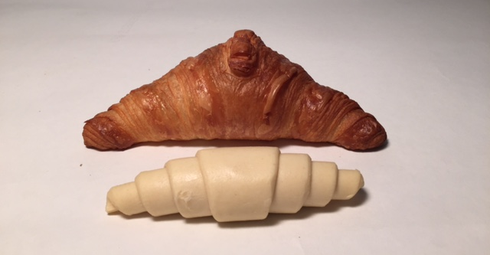

Baking advice NOT RISEN:
For a maximum result it is important to completely fill the baking tray with the same pastry and to follow the guidelines below.
The numbers for a full baking tray are listed for each reference on the attached list.
PUFF PASTRY:
- Defrost for at least 90 min
Defrosting can be done in a controlled fermation unit or on a baking cart covered with plastic foil
- Rise about 1h15min at 28 degrees (max 30°) with 78% moisture.
Do not let them rise too far, so bake in ‘green’ with the exception of butter roll with raisins.
Then insert immediately. This is important for a good crespness and shine. (don’t let it get crusty)
- Preheat the oven to 220°
Then bake of at 220° for 14min.
FIRST 7 MIN WITH STEAM! Then open the vapor key fort he last 7 min.

Baking advice RISEN

READY TO BAKE:

- Defrost for minimum 20 min.

- Bake for 21 min in a preheated oven
the first 14 min at 165°
the last 7 min at 200°
 | CRU products (not risen) | Number on baking plate
001 | CRU Buttercroissant | 15
003 | CRU Butterchocolate | 15
004 | CRU Butterchocolate with custard | 12
012 | CRU Butterrol without raisins | 15
011 | CRU Butterrol with raisins | 15
005 | CRU Raisin whirl | 12
007 | CRU Suisse longue with raisins | 16
008 | CRU Suisse longue with frangipan | 16
 | READY TO BAKE products | Number on baking plate
 | PREP Buttercroissant | 15
 | PREP Butterchocolate | 15
 | PREP Butterchocolate with custard | 15
 | PREP Raisin whirl | 12
 | PREP Suisse longue with raisins | 16
 | PREP Suisse longue with frangipan | 16
 | PREP Suisse longue with cinnamon | 16
 | PREP Suisse longue with custard  and chocolate | 16
 | PREP Maple pecan 98g
 | PREP MINI-Maple pecan
 | PREP MINI-Butterchocolate | 4x7
 | PREP MINI-Buttercroissant | 4x8
 | PREP MINI-Suisse longue custard | 4x8
 | PREP MINI-Raisin swirl | 4x7

